*REQUIREMENT:*

This is the requirement for an Online Admission form which helps the students to register the admission online. The user has to enter details like Username, Password, E-mail address, Occupation/Industry, Interested Area, Date of Birth, Country, State, City, Education level and contact number in the “Admission Form” to register the admission.

**Fields:**

* **“Account Information”**
  + Username – Textbox. This field can accept Alphabetic values of Maximum 30 characters in length.  It is a Mandatory Field.
  + Password – Textbox.  This field can accept Mix of Alphanumeric and special characters. The password length can be 8-15 Characters.  It is a Mandatory Field.
  + Email – Textbox. This field can accept Mix of Alphanumeric and special characters in a valid Email Format. It is a Mandatory Field.
  + **“Additional Required Information (Profile)”**
    - Occupation/Industry – Textbox. It is a Mandatory Field.
      * This field can accept Alphabetic values of Maximum 100 characters in length.
* Interested Area – Textbox. It is a Mandatory Field.
  + This field can accept Alphanumeric values and the maximum length is 100 Words.
* Date of Birth – Textbox. It is a Mandatory Field.
  + The Data Format is “DD/MM/YYYY”.
* Country – List box. It is a Mandatory Field.
  + The current values in database - “India”, “USA”.
* States – List box. The current values in database:
  + India – “Tamil Nadu”,” Karnataka”
  + USA – “Milwaukee”, “California”
* City/Area – List box. The current values in database:
  + Tamil Nadu – “Chennai”, “Coimbatore”
  + Karnataka – “Bangalore”, “Mysore”
  + Milwaukee –“Wisconsin”, “West Alice”
  + California – “Freemont”, “San Jose”

**Note**:  The “States” List box displays “States” based on the “Country” selected in the Country list box. Similarly, “City/Area” list box displayed the values based on the “States” selected. Hence, all the three List Boxes – Country, State and City/Area are inter-related.

**“Academic Information”**

* + Current Education Level – List box. The current values in database – B.E, M.B.B.S, B.Sc
  + Mobile Number – Textbox. This field can accept only numeric values of 10 digit. It is a Mandatory Field.
  + **“Privacy Settings”**
    - Checkbox – Receive Email from Administrators.
      * Valid Data – Checked or Unchecked
* Checkbox – I agree to the Privacy Policy and Terms and conditions of Admissionopen.com.
  + Valid Data – Checked or Unchecked. This checkbox has to be selected before Sign up/ Submit.
* Sign Up – Button.

**Validation:**

* The User after filling the form clicks the “Sign Up” Button. The application validates the data.
  + If the data is valid and the Check Box “I agree to the Privacy Policy and Terms and conditions of Admissionopen.com” is Checked, then the User receives the message “Successfully Registered” in the Next Page.
  + If the data is invalid, the User receives appropriate Error Message in the Next Page.

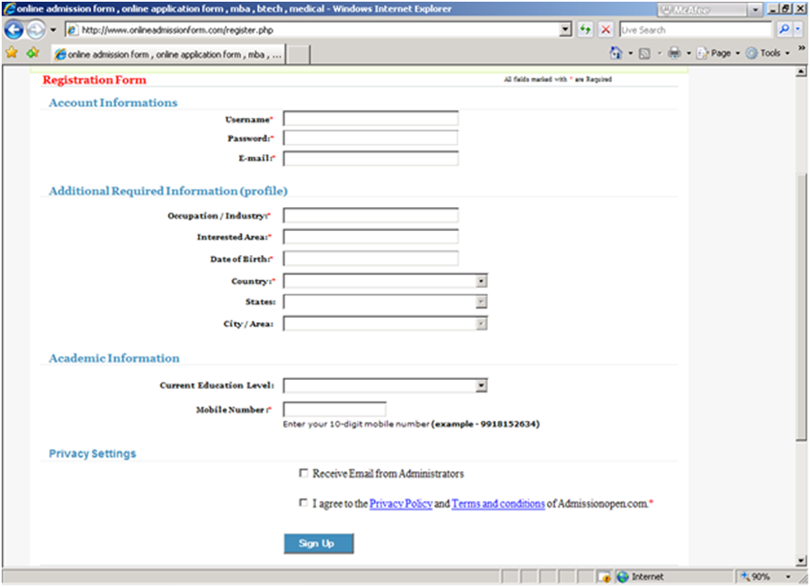

*Question 1:Identify all the test case for the above requirement*

*Question 2:Log the defect in a proper way so that any developer will understand. Provide all details for the below identified defect. For logging defect effectively read the requirement.*

*Write Defect Description for the below Cases.*

*a. The “City/Area” List box does not display Cities/Areas based on the selected “State”.*

*b. The Check Box “I agree to the Privacy Policy and Terms and conditions of Admissionopen.com”is Unchecked. The User clicks the “Sign Up” Button after filling all mandatory details. The Message, “Successfully Registered” is displayed.*

*c. The User fills the Registration Form and clicks the “Sign Up” Button. There is No Response.*